NAME: PUNUGUPATI GUNASRI
REG.NO: 192324103
DATE:17/12/25
DAY-4
16. Scenario: You are working on a project that involves analyzing customer reviews for a product.
You have a dataset containing customer reviews, and your task is to develop a Python program that
calculates the frequency distribution of words in the reviews.
Question: Develop a Python program to calculate the frequency distribution of words in the
customer reviews dataset?
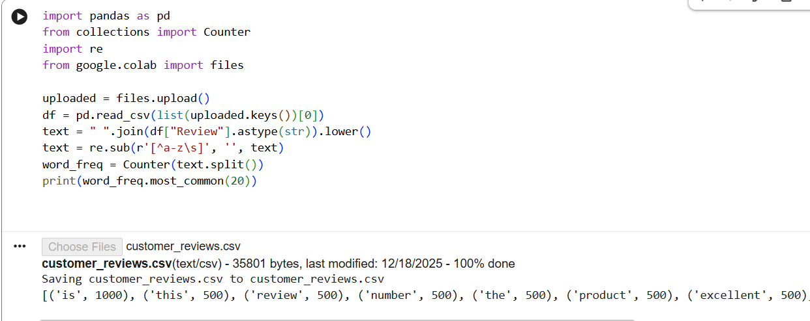
Code:
17. Scenario: You are a data analyst working for a marketing research company. Your team has
collected a large dataset containing customer feedback from various social media platforms. The
dataset consists of thousands of text entries, and your task is to develop a Python program to
analyze the frequency distribution of words in this dataset. Your program should be able to perform
the following tasks:
1.Load the dataset from a CSV file (data.csv) containing a single column named "feedback"
with each row representing a customer comment.
2.Preprocess the text data by removing punctuation, converting all text to lowercase, and
eliminating any stop words (common words like "the," "and," "is," etc. that don't carry
significant meaning).
3.Calculate the frequency distribution of words in the preprocessed dataset.
4.Display the top N most frequent words and their corresponding frequencies, where N is
provided as user input.
5.Plot a bar graph to visualize the top N most frequent words and their frequencies.
Question: Create a Python program that fulfills these requirements and helps your team gain
insights from the customer feedback data.
Code:
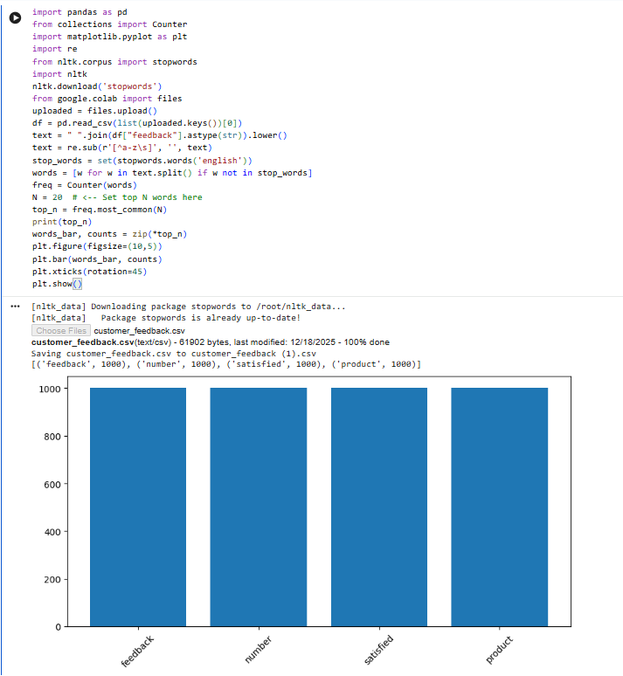
18. Scenario: Suppose a hospital tested the age and body fat data for 18 randomly selected adults with the
following result.
Question:
1. Calculate the mean, median and standard deviation of age and %fat using Pandas.
2.Draw the boxplots for age and %fat.
3.Draw a scatter plot and a q-q plot based on these two variables
Code:
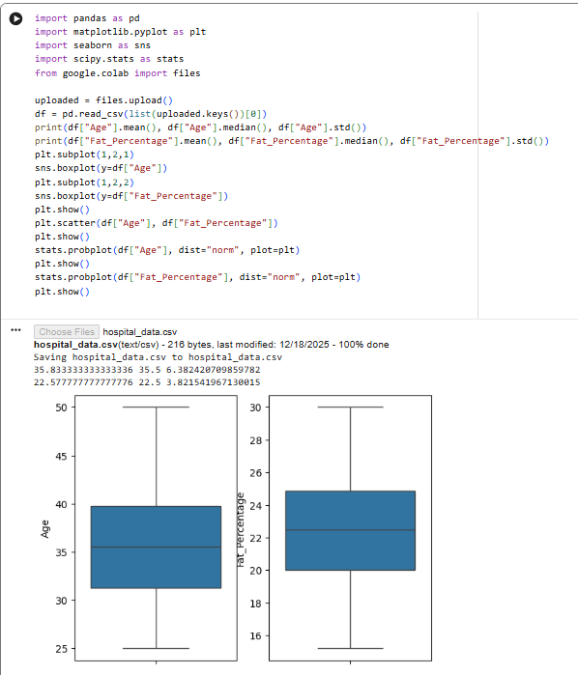
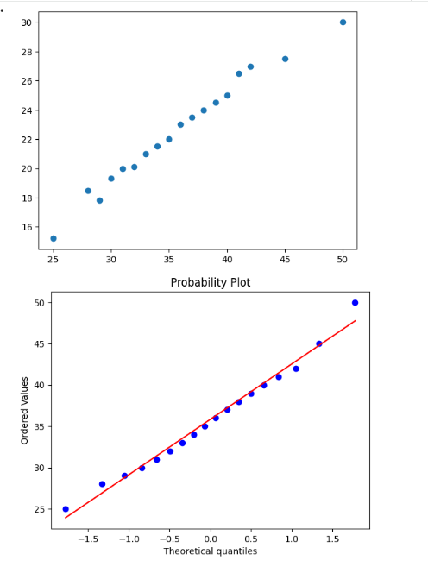
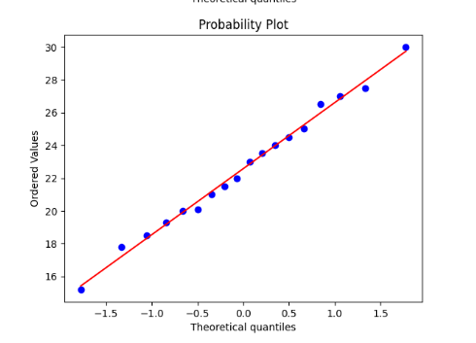
19. Scenario:
You are a medical researcher investigating the effectiveness of a new drug in reducing blood
pressure. You conduct a clinical trial with a sample of 50 patients who were randomly assigned to
receive either the new drug or a placebo. After measuring their blood pressure levels at the end of
the trial, you obtain the data for both groups. Now, you want to determine the confidence intervals
for the mean reduction in blood pressure for both the drug and placebo groups.
Question:
"What is the 95% confidence interval for the mean reduction in blood pressure for patients who
received the new drug? Also, what is the 95% confidence interval for the mean reduction in blood
pressure for patients who received the placebo?
Code:
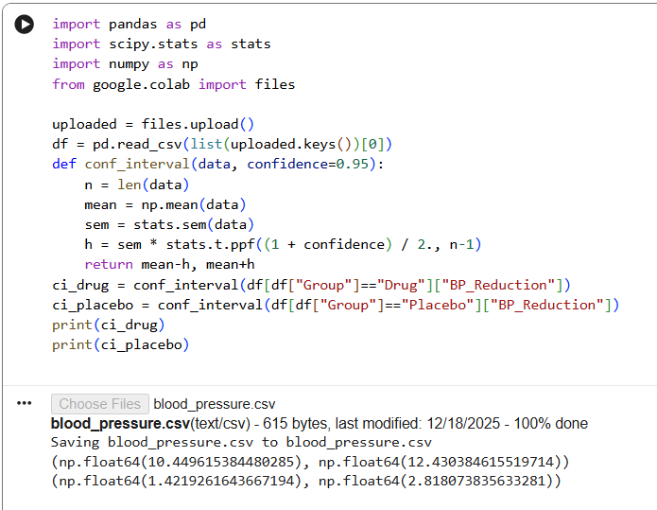

20. Scenario:
You are a data scientist working for an e-commerce company. The marketing team has conducted
an A/B test to evaluate the effectiveness of two different website designs (A and B) in terms of
conversion rate. They randomly divided the website visitors into two groups, with one group
experiencing design A and the other experiencing design B. After a week of data collection, you
now have the conversion rate data for both groups. You want to determine whether there is a
statistically significant difference in the mean conversion rates between the two website designs.
Question:
"Based on the data collected from the A/B test, is there a statistically significant difference in the
mean conversion rates between website design A and website design B?”
Code:
